Exercise #2
-- In the last exercise, we only added one value. So, for this exercise, we will be inserting these values into employee_data to broaden the scope of our next queries:
USE addressbook;
INSERT INTO employee (f_name, l_name, title, age, yos, salary, perks, email)
VALUES
('John', 'Santos', 'Software Engineer', 28, 3, 45000, 5000, 'john.santos@example.com'),
('Maria', 'Lopez', 'Project Manager', 34, 8, 65000, 12000, 'maria.lopez@example.com'),
('Carlos', 'Reyes', 'Data Analyst', 26, 2, 38000, 3000, 'carlos.reyes@example.com'),
('Anna', 'Dela Cruz', 'HR Specialist', 30, 5, 42000, 4500, 'anna.delacruz@example.com'),
('Michael', 'Tan', 'Senior Developer', 41, 15, 82000, 20000, 'michael.tan@example.com'),
('Kristine', 'Flores', 'UI/UX Designer', 27, 4, 40000, 3500, 'kristine.flores@example.com'),
('Ricardo', 'Marquez', 'Systems Administrator', 38, 10, 60000, 8000, 'ricardo.marquez@example.com'),
('Jenny', 'Lim', 'QA Engineer', 25, 2, 35000, 2500, 'jenny.lim@example.com'),
('Patrick', 'Chavez', 'Marketing Officer', 33, 7, 48000, 6000, 'patrick.chavez@example.com'),
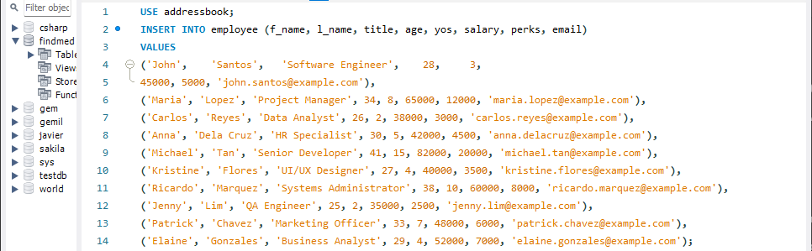
('Elaine', 'Gonzales', 'Business Analyst', 29, 4, 52000, 7000, 'elaine.gonzales@example.com');

1. Write the Select statement to extract the ids of employees who are more than 30 years of age.
SELECT * FROM employee_data WHERE age > 30;
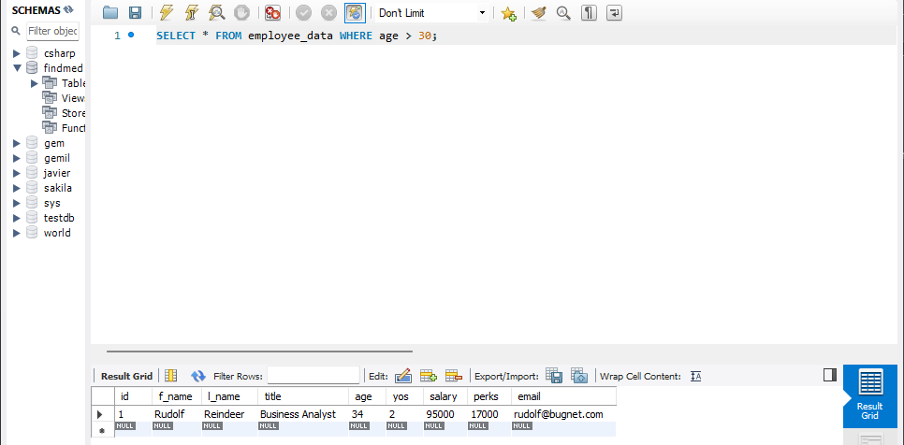
2. Write the select statement to extact the first and last names of all web designers.
SELECT f_name, l_name FROM employee_data WHERE title = "Web Designer";
-- Since we didn’t add any values with “Web Designer”, there won’t be any values. Of course, feel free to add our own spin to the values.
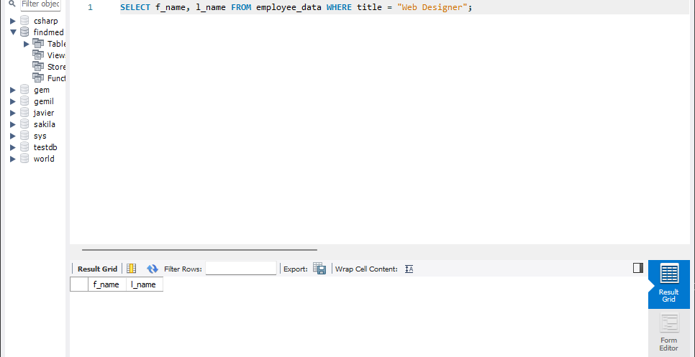

3. What will the following SELECT statement display:
SELECT * from employee_data where salary <= 100000;
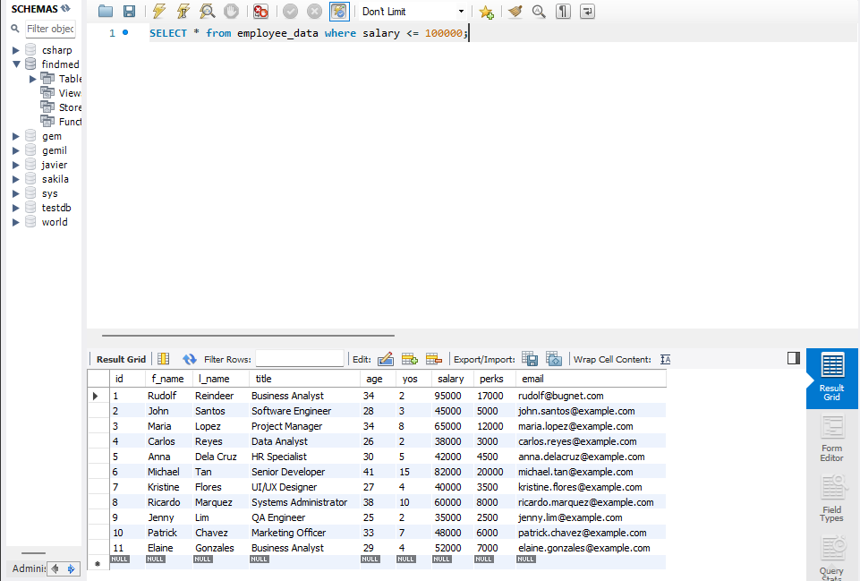
-- It will display all employees with salary less than or equal to $100,000.
4. How will you display the salaries and perks for employees who have more than $16000 as perks?
SELECT salary, perks from employee_data WHERE perks > 16000;
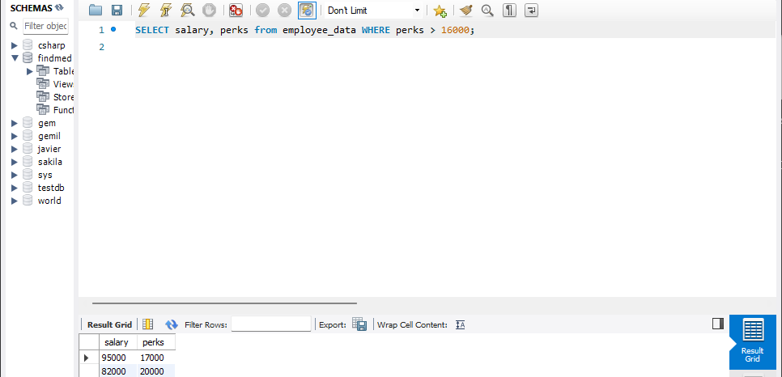
5. List all employee names (last name followed by first name) who hold the title of Marketing executive.
SELECT l_name, f_name FROM employee_data WHERE title = "Marketing Executive"
-- Like I said earlier, since we do not have a “Marketing Executive”, we will not have the data to display.
